**Chapter 1**

**Analyzing the system**

**Scenario**

In a so-called Contracting company one or several projects which are indicated by project ID, project name and project place are in the process. In these projects there are several workers and employers have activations who are known as Persons (account-party). These people are known by national number, personal number, first and last name and so on. Each person can be worker or employer and may participate in more than one project. After the contract which done by a contractor and he announce the details of the project to the employer(s). Details such as how the project be done, when to begin and also the deadlines. Afterwards the employer will inform the workers and all the human resources about the information. Each employer must monitor all the subset systems operations.

In each project, costs such as salaries, water costs, electricity costs, vehicle fuel costs, etc. are spent, and each cost is identified by the name and type of cost. With every expenditure, an accounting document is also recorded, which is specified by the document number, date and amount of the document. In addition to that, other accounting office’s such as general journal, ledger and subsidiary ledger are also needed.

After the end of each working period, the accounting union supervises all the actions registered in the company and any embezzlement and abuse are identified.**Entities in the design**

1. **Accounting Document**
2. **Person (Account-Party)**
3. **Project**
4. **Cost**

|  |  |
| --- | --- |
| **Description** | **Entity** |
| There are projects that we are currently working on or will work on in the future | **Project** |
| Account parties are those with whom we are financially connected in some way | **Person** |
| All required accounting actions can be done using accounting documents | **Accounting Document** |
| Costs such as: salaries, telephone, electricity, water and fuel costs that are spent in each project. | **Cost** |

**Table 1-1 Description of entities**Charts and diagrams

ER Chart – Accounting Document Entity

Figure 1-1 Accounting document entity

Accounting Document

**Description of accounting document attributes and each one status**

**Document number:** identifier, based, no immutable value, simple

**Document Date:** not identifier, based, no immutable value, simple

**Document Amount:** not identifier, based, no immutable value, simple

**Document Description:** not identifier, based, no immutable value, simple

**Person Entity:**

Figure 1-2 Person Entity

Person

Phone Number

**Has**

**N**

**1**

**Description of Person entity attributes and each one status**

|  |  |  |  |  |  |  |  |  |
| --- | --- | --- | --- | --- | --- | --- | --- | --- |
| **(Field Name)** | | | **Identifier** | | **Null able** | **Simple** | **Base** | **Multivalued** |
| **National No.** | | | **\*** | | **\*** | **\*** | **\*** |  |
| **Personal No.** | | |  | | **\*** | **\*** | **\*** |  |
| **Name** | | |  | | **\*** | **\*** | **\*** |  |
| **Father Name** | | |  | | **\*** | **\*** | **\*** |  |
| **Vehicle Type** | | |  | | **\*** | **\*** | **\*** |  |
| **Job** | | |  | | **\*** | **\*** | **\*** |  |
| **Address** | | **Home** | |  | **\*** |  | **\*** | **\*** |
| **Work** |  | | **\*** |  | **\*** | **\*** |
| **Phone** | **Home** | |  | | **\*** | **\*** | **\*** |  |
| **Work** | |  | | **\*** | **\*** | **\*** |  |
| **Mobile** | |  | | **\*** | **\*** | **\*** |  |

Table 1-2 Person Entity Attributes

**Project Entity:**

Figure 1-3 Project Entity

Project

**Description of Project entity attributes and each one status**

|  |  |  |  |  |  |
| --- | --- | --- | --- | --- | --- |
| **(Field Name)** | **Identifier** | **Null able** | **Simple** | **Base** | **Multi valued** |
| **Project No.** | **\*** | **\*** | **\*** | **\*** |  |
| **Name** |  | **\*** | **\*** | **\*** |  |
| **Type** |  | **\*** | **\*** | **\*** |  |
| **Description** |  | **\*** | **\*** | **\*** |  |

Table 1-3 Project Entity Attributes

**Cost Entity:**

Cost

Figure 1-4 Cost Entity

**Description of Cost entity attributes and each one status**

|  |  |  |  |  |  |
| --- | --- | --- | --- | --- | --- |
| **(Field Name)** | **Identifier** | **Null able** | **Simple** | **Base** | **Multi valued** |
| **Cost No.** | **\*** | **\*** | **\*** | **\*** |  |
| **Name** |  | **\*** | **\*** | **\*** |  |
| **Type** |  | **\*** | **\*** | **\*** |  |
| **Description** |  | **\*** | **\*** | **\*** |  |

Table 1-4 Cost Entity Attributes

Entities Relations:

Person

Phone

**Has**

**N**

**1**

Project

**Working**

**N**

**M**

Cost

**Spend**

Figure 1-5 Entities Relations

**Contracting Company Context Diagram**

Figure 1-6 Contracting Company Context Diagram

**Data Flow Diagram (DFD)**

Working in Projects

Register Documents

Completing Projects

Expenditure

Earn Salary

Make Contract

Contracting Company

**Contracting Company**

**Worker**

**Does tasks as requested**

**2**

**Accounting Document**

**Accountant**

**Registers All Accounting operations**

**3**

1

**1**

**Contractor**

**Monitor Workers performance**

Performance criteria

Performance Check

Describe how begin and end the project

Monitor the Accounting Books

Performance report

**UML**

Figure 1-7 Data Flow Diagram

**Class Chart**

**In this system we are using 5 classes as follows:**

1. **Human Class:** All other classes are inheriting this class properties. In fact this class is an abstract class.
2. **Employer Class**
3. **Worker Class**
4. **Accountant Class**
5. **Contractor Class**

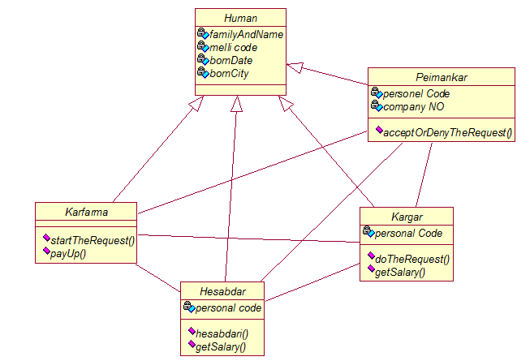

Figure 1-8 Class Chart

**Actor**

**We are looking at the system from the employer perspective. In fact employer makes profit from the system and he is the starter of the operations.**

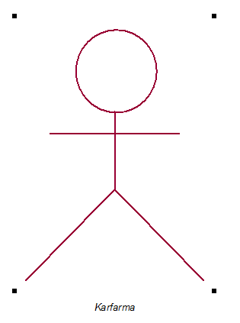

Figure 1-9 Employer

**Entities**

Actually we need some entities on our system in which specific information would be stored. Described below:

**Persons Information:** We store all persons information involved in the system.

**Projects Information:** In this entity we have all the project related information.

**Costs Information:** In this entity we have all the costs related information.

**Documents Information:** We have information regarding the accounting documents and their attachments.

**Assigned Projects List:** In this entity we store all assigned projects information.

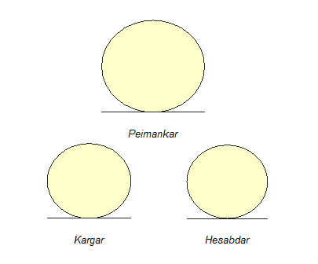

Figure 1-10 Entities in UML

**Use Case**

**We have 3 specific activities in our system:**

1. **Cost:** In every project there are several cost expenditure.
2. **Work:** In every project there are miscellaneous work will be done until the project complete.
3. **Income:** In case of project success.

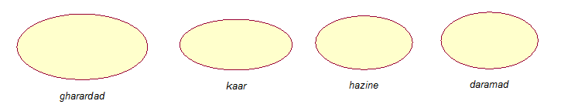

Figure 1-11 UML Use Case

**Business Worker**

Business worker is someone who provide some services for the business actor.

1. **Worker:** Someone who get all the physical tasks done in exchange for salary received.
2. **Contractor:** The contractor is responsible for monitoring workers and accountants.
3. **Accountant:** Accountant is responsible for all costs and financial operations expenditure in order to know how money is being spent.

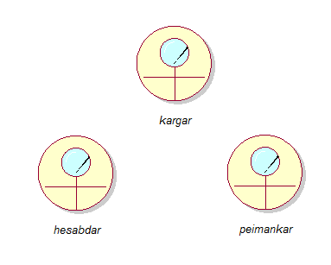

Figure 1-12 UML Business worker

Use Case Chart

**The employer is the starter of the entire operation in our system. At first place the employer delivers his/her request to the contractor, then in case of acceptance, a contract will be made between company and the employer. After making the contract in a specific date, the operation will begin. The project achievement should be reached at the specified date. First there will be an exact amount of credit for the project which should be provided by the contractor. This amount is considered as costs. Meanwhile the employer job is to control and monitor workers and accountants. Workers and accountants in the other hand will receive salary for their work which is considered also as costs. Finally the contractor will pay the contract amount to the employer which considered ad income of the company.**

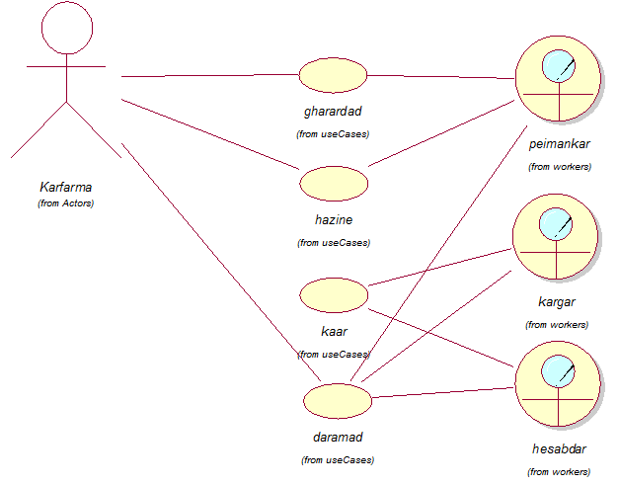

Figure 1-13 Use case Chart

**Base Features of the Application**

**Main features are:**

1. **User Section:**

* Defining Contracting Projects
* Defining financial account party (e.g. employees, workers, …)
* View Accounting Journal/Ledger/Details
* View projects details
* View Trial Balance (two-columns and four-columns)
* View Balance Sheet
  + View Accounts codes and accounting documents

1. **Management Section:**
   * Issuance of pay stubs
   * Finance and cheque actions
   * Register accounting documents
   * Essay register ability
   * Application Configurations
   * Account opening
   * Manage chart of accounts
   * Database Configurations
   * Issuance of leave permissions
   * Users managements
   * Assigning users access permissions